GCSE Student Guide
for External Examinations

Introduction

It is the aim of Strathearn School to make the examination experience as stress-free and successful as possible for all candidates.
Hopefully, this booklet will prove informative and helpful for you and your parents. Please read it carefully and show it your parents so that they are also aware of the examination regulations and the procedures to follow in the event of any problems occurring.

Mrs Connery, as Principal of the School, is head of the Strathearn Examination Centre. The administration of GCE and GCSE examinations is the responsibility of the Examinations Officer, Mrs Norris.

The Awarding Bodies (or Examination Boards) set down strict criteria which must be followed for the conduct of examinations and Strathearn School is required to follow them precisely. You should therefore pay particular attention to the Notice to Candidates that is printed on Appendix 1.

Answers to some common questions can be viewed in Appendix 2. An exam check list has also been provided at Appendix 3.

If there is anything you do not understand or any question that has not been addressed, PLEASE ASK.

If you, or your parents, have any queries or need help or advice at any time before, during or after the examination please contact: The Vice Principal (Teaching and Learning) or the Examinations Officer, Mrs Norris. The school telephone number is: 9047 1595.

Remember – we are here to help.

- Although we encourage all students to arrive in plenty of time to avoid a last minute panic, it is important that we have up-to-date contact telephone numbers for both you and your parents, or anybody else who might be able to help in an emergency. If you have recently moved or changed telephones numbers, please alert reception.

- Please save the school telephone number 9047 1595 on your mobile phone (if you will be carrying one) so that you can phone in if you have a serious problem on your journey to school.

Equipment:
- Make sure that you have all the correct equipment before your examinations. Check the regulations in the Notice to Candidates (Appendix 1) and the information on the following pages.

Special Arrangements:
- Special Arrangements are made for those pupils who have permanent or long term disabilities and/or learning difficulties and, where appropriate, for those pupils who suffer temporary disabilities, illness and indispositions during the examination period. After consultation with the SENCO, Mrs Norris will make an application to the relevant Awarding Bodies for the appropriate Special Arrangement to be approved.

Special Consideration:
A candidate may be eligible for Special Consideration if:
- Performance in an examination is affected by circumstances beyond the control of the candidate, e.g. recent personal illness, bereavement.
- Part of an examination is missed due to circumstances beyond the control of the candidate e.g. an accident (note that there are minimum examination requirements that need to be met for a grade to be awarded).
Parents should contact Mrs Myers regarding Special Consideration. Evidence, e.g. a doctor’s letter, may be required to support the application. Mrs Norris applies to the relevant Awarding Body for Special Consideration to be given to a candidate. The Awarding Body decides the level of consideration given to a candidate, but parents should be aware that no feedback is ever given.

Timetables:
- You have received an individual timetable showing your own specific examinations with details of date, time and duration of exam. Check it carefully – if you think something is wrong see Mrs Norris immediately.

- Some candidates may have a clash where 2 exams are timetabled at the same time. The school will make special timetable arrangements for these candidates. Mrs Norris will make each candidate aware of how their clash has been resolved and check that they are happy with the arrangement. If you think there is a clash on your timetable that has not been resolved, please see Mrs Norris immediately.

Awarding Bodies
All GCSEs are taken with CCEA.

During the Examinations

Examination Regulations:
- A copy of the ‘Information for Candidates’ notice for written exams which is issued jointly by all Awarding Bodies, is printed at Appendix 1 of this booklet. All candidates must read these carefully and note that to break any of the examination rules or regulations could lead to disqualification from all subjects. The school must report any breach of regulations to the Awarding Body.

Attendance at Examinations:
- Candidates are responsible for checking their own timetable and arriving at school on the correct day and time, properly dressed and equipped. Candidates must arrive at least 15 minutes prior to the start time of their examinations. Please wait quietly outside the exam venue until you are invited to enter by the examination invigilators.

- All items of equipment, pens, pencils, mathematical instruments etc., should be visible to the invigilators at all times. You must either use a transparent pencil case or clear plastic bag.

- Pens should be black ink or ballpoint only. NO erasers, highlighter, gel pens or correction pens are allowed.

- For Mathematics and Science Exams, students should check their calculators conform to the examination regulations – see Appendix 5. If in doubt, check with your teacher. Remove any covers or instructions and clear anything that has been stored in the calculator. Please make sure batteries are new.

- Candidates are not to bring mobile phones or other electrical devices such as IPods, smart Watches, MP3 players, pagers, reading pens or any other products with text or digital facilities into the examination room. If candidates have unauthorised items in an examination, this may represent malpractice and lead to disqualification. The school would have to forward a report to the Awarding Body. Any mobile phones/smart Watches that are accidentally brought in must be switched off and handed to the Invigilator at the start of the examination – they must not be left in your pocket. Even if you do not intend to use it but it is still in your procession you will be subject to a penalty. In the past this has been awarding the candidates 0 marks in that unit. If you so much as lift the phone out of your pocket this is regarded as a Sanction 5 which results in disqualification from the exam series.

- All wrist watches must be removed and left on your exam desk. Smart watches or any watch with additional functionality over and above telling the time are not permitted. They should be treated in the same way as mobile phones.

- Please can you also ensure that you have emptied your pockets of any loose notes. Even if you don’t intend to use these they can easily drop out of your pocket during an exam. If this happens it will be viewed as malpractice and sanctions, similar to those outlined about will be enforced. Pupils should get into the way checking their pockets before they enter the exam venue.

- Listen carefully to instructions and notices read out by the invigilators – there may be amendments to the exam paper that you need to know about.

- Check you have the correct question paper – check the subject, paper and tier of entry.

- Read all instructions carefully and number your answers clearly. Make sure you have filled in all the details on the front of the exam paper. You will be given a chance to do this before the exam starts.

- If you have finished the paper use any time remaining to check over your answers and ensure you have completed your details correctly.

- At the end of the examination all work must be handed in – remember to cross out any rough work neatly but do not make it illegible as it will be forwarded to the examiner. If you have used more than one answer book or loose sheets of paper ask for a treasury tag to fasten them together in the correct order.

- It is your responsibility to ensure you produce legible writing.

- Invigilators will collect your exam papers before you leave the room. Silence must be maintained during this time. Remember you are still under examination conditions until you have left the room and any communication between candidates may be viewed as malpractice.

- Question papers, answer booklets and additional paper must NOT be taken from the exam room.

- Remain seated in silence until told to leave the examination room. Please leave the room in silence and show consideration for other candidates who may still be working.

- You must not leave the hall during an exam without being accompanied by an invigilator. If you do, you will not be permitted to return.

- If the fire alarm sounds during an examination the examination invigilators will tell you what to do. Don’t panic. If you have to evacuate the room you will be asked to leave in silence and in the order in which you are sitting. You will be escorted to the designated assembly point in the back car-park. Leave everything on your desk. You must not attempt to communicate with anyone else during the evacuation. When you return to the exam room do not start writing until the invigilator tells you to. You will be allowed the full working time for the examination and a report will be sent to the Awarding Body detailing the incident.

Invigilators

- The school employs external invigilators, led by Mrs Millar, to conduct the examinations in a number of venues around the school. Students are expected to behave in a respectful manner towards all invigilators and follow their instructions at all times.

- Invigilators are in the examination rooms to supervise the conduct of the examination. They will distribute and collect the examination papers, tell candidates when to start and finish the examination, hand out extra writing paper if required and escort pupils if they need to leave the hall.

- If a pupil has any concerns during the examination, do not hesitate to highlight them to the invigilators.

- To attract the invigilator’s attention, raise your hand and wait for the invigilator to come to you.

- Invigilators cannot discuss the examination paper with you or explain the questions. They will simply instruct you to read the questions/instructions again.

What to do if you are ill on the day of the exam

- If you are ill and are unable to attend an exam it is vital you phone the school first thing in the morning to inform us.

- You must also obtain a note from your doctor detailing the reason for non-attendance. There is the possibility of submitting this note to the Awarding Body to ask for Special Consideration.

- If you are feeling unwell, but still able to travel, I suggest you come to school and we can assess the situation then. In most cases it is better to take the exam, if you can.

- If in doubt – PHONE THE SCHOOL.

After the Examinations

Notification of Results

You will receive you results via post on Thursday 22 August.

Results will only be given out over the phone after a number of security questions are answered.

Post Results
If you need post results advice, school staff will be available on Results Day. The following services are available:

Enquiry about Results

- Review of Marks
- Access to Scripts

There is a charge for these services. The Awarding Bodies have set deadlines for the submission of requests for review of marks, access to scripts and appeals. Information is issued with the results regarding the deadlines, cost and other matters relating to the Post Result Services available to pupils.

Pupils may speak to Mrs Norris or their subject teacher for advice on the review of marking process but ultimately the final decision rests with the candidate. It will be the candidate who signs the consent form and submits payment to the Awarding Body.

Before a pupil can submit a review of mark request they must complete a consent form. This is a signed acknowledgement that a review of marking may result in marks going up, leading to a grade change but it may also lead to a drop in marks which can lead to a grade being lowered. If a grade is lowered it cannot be reinstated.

If a pupil has any concerns regarding the outcome of a marks review, they should contact Mrs Norris as soon as possible to discuss the Appeals Procedure set up by the Awarding Bodies. Appeals are made by the school on the behalf of the pupil. Please note that there is a deadline of 30 calendar days after the receipt of the outcome of a mark review in which the school may instigate an appeal. Pupils may also wish to discuss their concerns with the relevant Head of Department, but should not delay in informing Mrs Norris of a possible appeal being made.

Please note that candidates and/or their parents/carers are not entitled to appeal directly to the awarding body. Representations must be made to the head of centre where the candidate was entered or registered. It will be the head of centre’s decision as to whether to proceed with an appeal.
Appendix 1

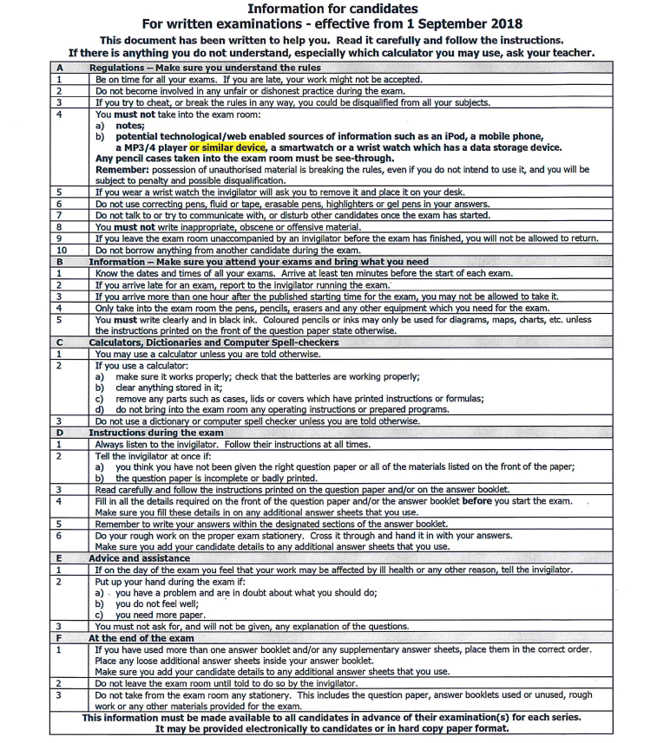

Appendix 2

RESULTS

You will receive your results via post on Thursday 22 August.

Result packs will be posted home to the address we currently have stored on the system.

If you would like your results posted to an address other than what we hold on the system please complete the form below and return it to Mrs L Wright, School Secretary, Strathearn School.

Name of Student: ______________________________________

Address to which results should be sent (if not home address). Please include post code:

_______________________________________________________
_______________________________________________________
_______________________________________________________
_______________________________________________________

Appendix 3

FREQUENTLY ASKED QUESTIONS

Q What do I do if there is a clash on my timetable?
A Mrs Norris will re-schedule one of your exams and issue a new revised timetable for that day. If the combined time of the 2 exams is more than 3 hours, candidates will sit one paper in the morning and one in the afternoon. Otherwise the papers will be done one after each other. When candidates take an exam earlier or later than the published start time they will be supervised for the duration and must not have any communication with other candidates. It will be necessary for you to bring a packed lunch if you have exams in the morning and afternoon as you will have to remain in isolation until both examinations are completed. If in doubt consult Mrs Norris. Please remember to bring all material for the second exam when you turn up to sit your first exam and leave this at the front of the exam hall for collection before you go into isolation. When you are in isolation you must give your mobile phone and any other electronic device to the supervisor. Failure to do so could lead to disqualification penalties. You will be escorted to the bathroom and whilst there must not communicate with any other pupil.

Q What do I do if I think have the wrong paper?
A Invigilators will ask you to check the paper before the exam starts. If you think something is wrong put your hand up and tell the invigilator immediately.

Q What do I do if I forget my Candidate Number?
A Candidate numbers are printed on desk cards on the top corner of your allocated desk.

Q What do I do if I forget the School Centre Number?
A The Centre Number is 71279. It will be clearly displayed in the examination rooms.

Q What do I do if I have an accident or am ill before the exam?
A Inform the school at the earliest possible point so we can help or advise you. You may need to obtain medical evidence (from your GP or hospital) if you wish the school to make an appeal for Special Consideration on your behalf (see below). Please speak to Mrs Myers.

Q What is Special Consideration?

A Special consideration is a post-examination adjustment to a candidate’s mark or grade to reflect temporary illness, temporary injury or other indisposition at the time of the assessment, which has had, or is reasonably likely to have had, a material effect on a candidate’s ability to take an assessment or demonstrate her normal level of attainment in an assessment. The maximum allowance given will be 5% of the total raw marks available in the component concerned however, parents should be aware that any adjustment is likely to be small and no feedback is ever provided. Candidates will only be eligible for Special Circumstances if they have been fully prepared and covered the whole course but performance in the examination or in the production of coursework is affected by adverse circumstances beyond their control. The Examination Officer must be informed immediately, so that the necessary paperwork can be completed and the candidate will be required to provide evidence to support such an application. Special Consideration must be applied for during the exam series. It cannot be applied once results have been received.

Q What do I do if I feel ill during the exam?

A Put your hand up and an invigilator will assist you. You must not leave the exam hall unsupervised. If you do this, you will not be permitted back in to sit the remainder of the exam.
If you feel ill before the exam starts inform Mrs Norris and the invigilators. If you feel this may have affected your performance speak to Mrs Norris directly after the exam.

Q If I am late can I still sit the examination?

A Provided you are not more than 1 hour late after the published start time, it may still be possible for you to sit the examination. You should get to school as quickly as possible and report to Reception. If possible, contact the school to inform us you are running late. A member of staff will escort you to the examination room. You must not enter an examination room without permission after an examination has begun. If may not be possible to allow you any extra time if you start the examination late.

If you arrive at school more than 1 hour after the published start time, the school must inform the Exam Board and it is very likely that the Board may decide not to accept your work.

Please ensure that you allow enough time to get to school so that if you are delayed (e.g. through transport problems) you will still arrive on time.

Q If I miss the examination can I take it on another day?

A NO. Timetables are regulated by the Awarding Bodies and you must attend on the given date and time.

Q How do I know how long the exam is?

A The length of the examination is shown in minutes on your individual timetable under the heading ‘duration’. Invigilators will tell you when to start and finish the exam. There will be a clock in all the examination rooms. There will also be a board at the front of the exam hall that will specify the duration of each exam.

Q Can I go to the toilet during the exam?

A If it is absolutely necessary. You will be escorted by an invigilator but will not be allowed any extra time.

Q If I have more than one exam on a day can I get lunch at school?

A Pupils who have examinations in the morning and afternoon sessions may obtain lunch from the canteen in the usual way or bring a packed lunch.

Appendix 4

EXAM CHECK LIST
- Aim to arrive at school 15 minutes prior to an exam. It is much better to leave yourself a safety margin on timings in case you encounter problems on the journey.

- When taking exams, bags and coats should be left in Changing Room 1 in the Sports Hall. Please do not leave anything valuable in your bag.

- You are not allowed to have notes, papers, IPods, MP3 players, smart Watches, mobile phones in your possession.

- You should bring a BLACK pen, pencil, rubber and any other writing equipment needed to do your exams. Only clear pencil cases are allowed on your desk, any others should be left in your bag. Do not use gel pens – this is because many of the exam papers are now scanned and sent electronically for marking – gel pens do not scan well.
- In an exam where you have the use of a calculator, you should not have a calculator cover with you.

- You are responsible for ensuring your calculator is working. You are not permitted to borrow a calculator from another candidate during the exam session.

- There must be no talking or communication between students once you enter the exam hall. If you have any questions, you should raise your hand once seated and an invigilator will come to you.
- No food is allowed in the exam hall. If you have a special requirement – please see Mrs Norris, Exams Officer, before the exam.
- Water bottles are allowed in the exam hall if necessary. There should be NO LABEL on the bottle.

- If you have an exam clash you must bring all notes for both exams when you arrive for your first exam. These notes must be left at the front of the hall for collection after your first exam.

Appendix 5
