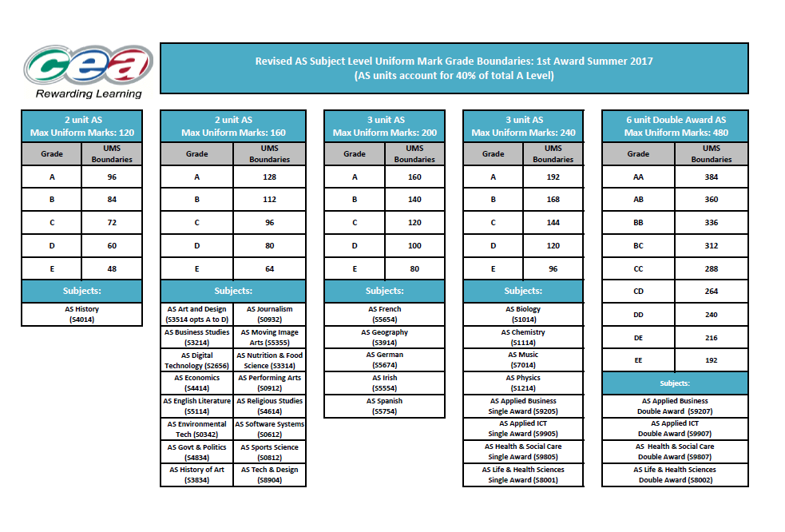
CCEA Maths, WJEC and AQA grade boundaries are overleaf.

Maths
Maximum mark 300
A | 240
B | 210
C | 180
D | 150
E | 120

Media Studies
Maximum mark 200
A | 160
B | 140
C | 120
D | 100
E | 80

Physical Education
Maximum mark 200
A | 160
B | 140
C | 120
D | 100
E | 80

